**Experiment – 4**

Entity Relationship Diagram:

ER Diagram is known as Entity-Relationship Diagram. It is used to analyse the structure of the Database. It shows relationships between various entities and their respective attributes. An ER Model provides a means of communication and elucidates on it in detail all graphically.

The Library Management System database keeps track of readers with the following considerations –

* It monitors the personnel using a unified authentication method that includes a login ID and password.
* The librarian updates the book catalog, which includes the ISBN, title, price (in INR), category (novel, general, story), edition, author number, and information.
* A publisher possesses a publisher ID, the year the book was released, and the title of the book.
* Readers are registered using their user_id, email, first name, last name, phone number ,and communication address. The personnel monitors the readers.
* Readers are able to return or reserve books that have the issue date and return date stamped on them. If not returned by the specified time frame, it could also have a due date.
* Staff also create reports that include reader IDs, report registration numbers, book numbers, and issue/return information.

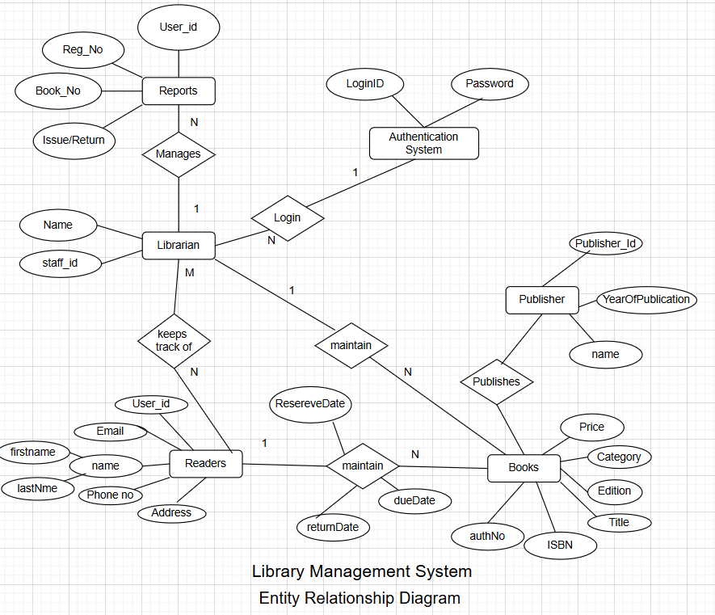

This Library ER diagram showcases essential details regarding the Library, featuring entities like Librarian, Readers, Books, Publishers, Reports, and the authentication system. It enables comprehension of the connections among entities.  
  
Entities and their Attributes :–

* Book Entity: It includes authno, isbn code, title, edition, category, and price. ISBN serves as the Primary Key for the Book Entity.
* Reader Entity: It includes UserId, Email, address, phone number, and name. Name is a composite attribute comprising firstname and lastname. The phone number is a multi-valued attribute. UserId serves as the Primary Key for the Readers entity.
* Publisher Entity: It includes PublisherId, publication year, and name. PublisherID serves as the Primary Key.
* Authentication System Entity: It includes a LoginId and password, with LoginId serving as the Primary Key.
* Reports Entity: It includes UserId, Reg_no, Book_no, and Issue/Return date. Reg_no serves as the Primary Key for the reports entity.
* Library Entity: It possesses a name and staff_id, staff_id designated as the Primary Key.
* Reserve/Return Relationship Set: It consists of three attributes: Reserve date, Due date, and Return date.

Relationships Among Entities :–

* A reader is allowed to reserve N books, but a single book may only be reserved by one reader. The relationship is 1:N.
* A publisher is able to release numerous books, whereas a book is released by just one publisher. The relationship is 1:N.
* Librarian monitors readers. The relationship is M:N.
* Librarian manages various reports. The relationship is 1:N.
* Librarian oversees numerous books. The relationship is 1:N.
* The authentication system allows various staff members to log in. The relationship is 1:N.